UNIVERSITY OF ENGINEERING AND TECHNOLOGY
PESHAWAR, PAKISTAN
DATA STRUCTURES
Weeks 4
Lab Assignment
Name | Anas Khan
Department | Computer Science
Section | B
Registration Number | 25PWCS1691
Submitted to | Sir Mudasir
University | University of Engineering and Technology, Peshawar, Pakistan

Exercises 1: Trace Binary Search by Hand

Exercises 1
Task 1:
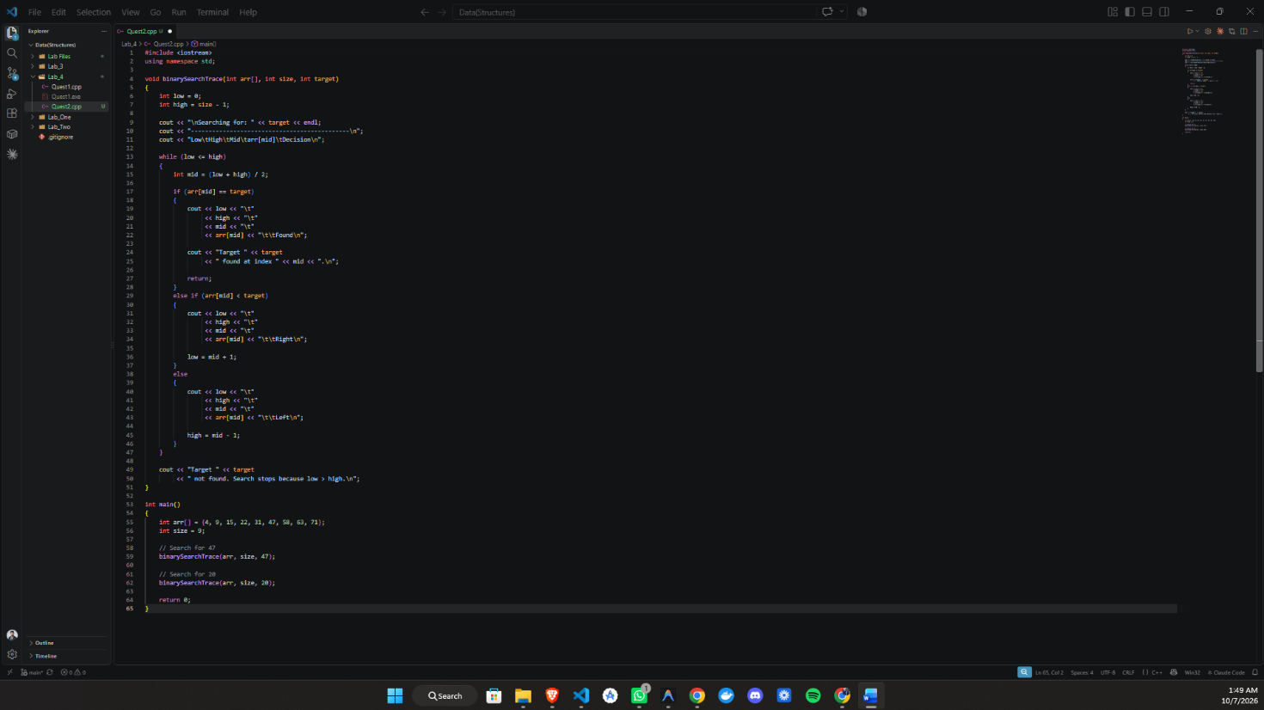
Understand how the search interval changes.
Code:
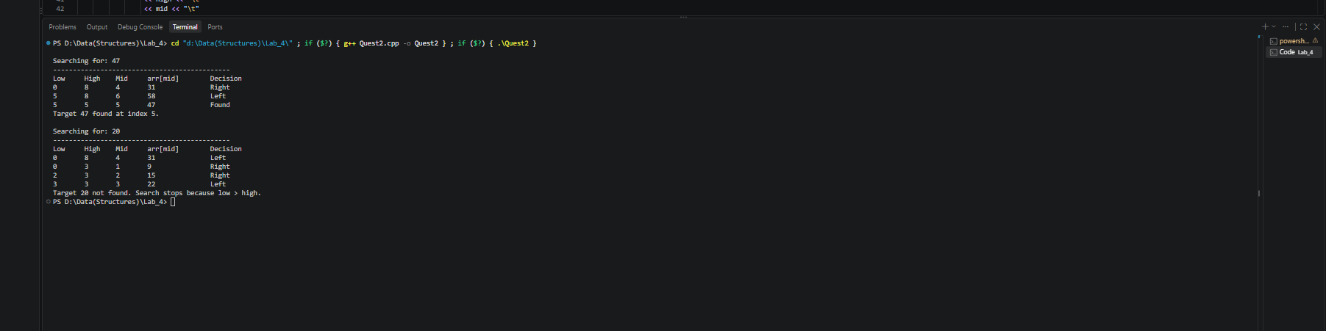
Output:

Explanation:
Index: 0 1 2 3 4 5 6 7 8
Value: 4 9 15 22 31 47 58 63 71
1. Search for target = 47
Initially:
- low = 0
- high = 8
- mid = (low + high) / 2
Iteration | low | high | mid | arr[mid] | Decision
1 | 0 | 8 | 4 | 31 | 47 > 31 → Right
2 | 5 | 8 | 6 | 58 | 47 < 58 → Left
3 | 5 | 5 | 5 | 47 | Found
Result: Target 47 is found at index 5.
2. Search for target = 20
Initially:
- low = 0
- high = 8
Iteration | low | high | mid | arr[mid] | Decision
1 | 0 | 8 | 4 | 31 | 20 < 31 → Left
2 | 0 | 3 | 1 | 9 | 20 > 9 → Right
3 | 2 | 3 | 2 | 15 | 20 > 15 → Right
4 | 3 | 3 | 3 | 22 | 20 < 22 → Left
After iteration 4:
- low = 3
- high = 2
Since low > high, the search interval is empty and the search stops.
Result: Target 20 is not found in the array.
Final observation
- For 47, binary search finds the target in 3 iterations at index 5.
- For 20, binary search performs 4 iterations, then stops when low > high, confirming that 20 is not present.

Task 2:
Implement Iterative Binary Search & Convert the trace logic into working C++ code.

Code:
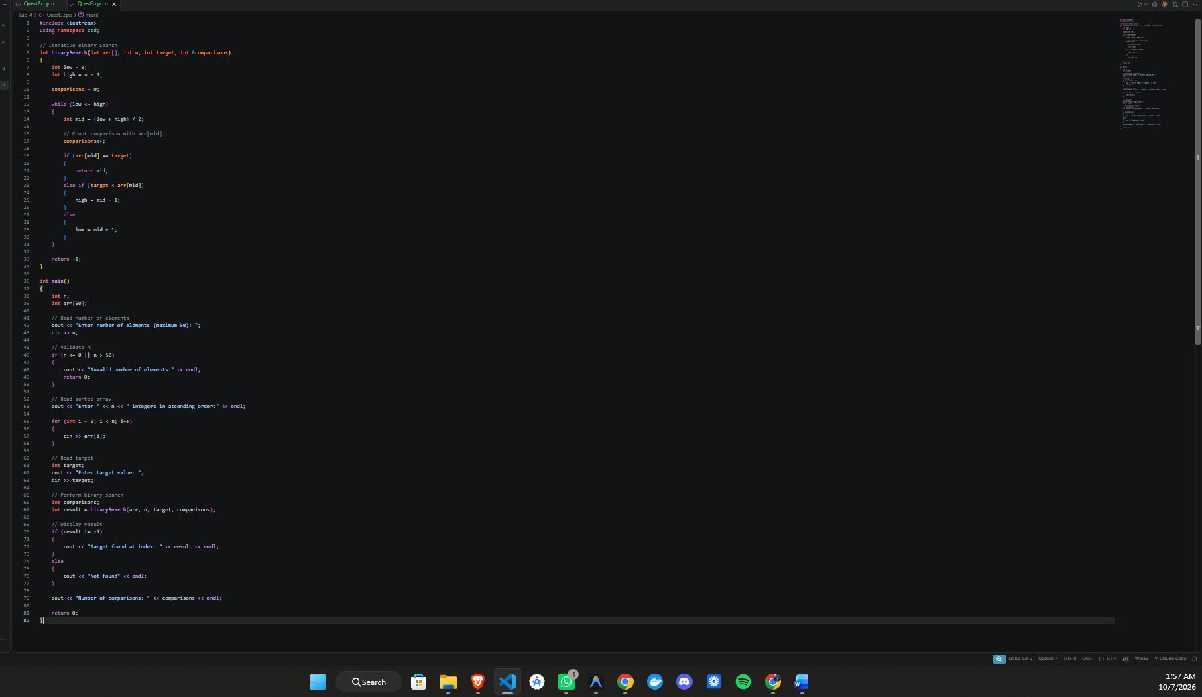
Output:

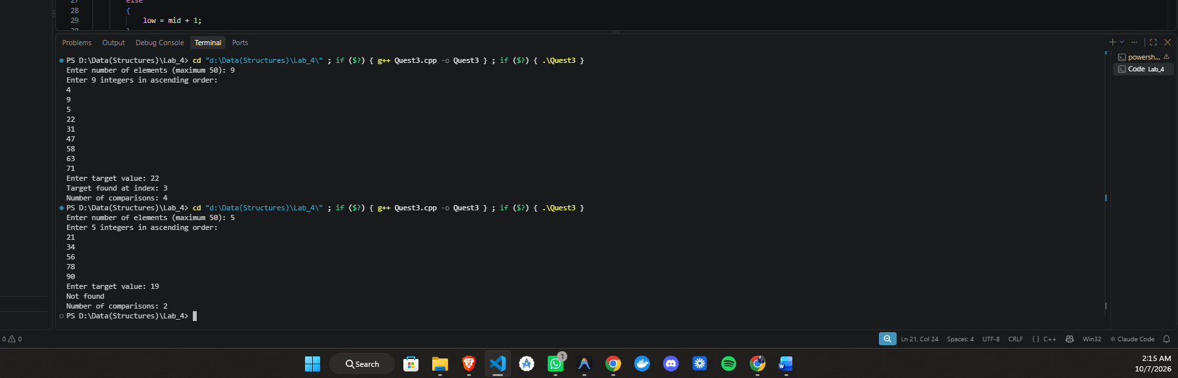

Task 3:
Implement Recursive Binary Search and Understand the same decisions through recursive function calls. And Submit: C++ program + a short note comparing iterative loops with recursive calls.
Code:
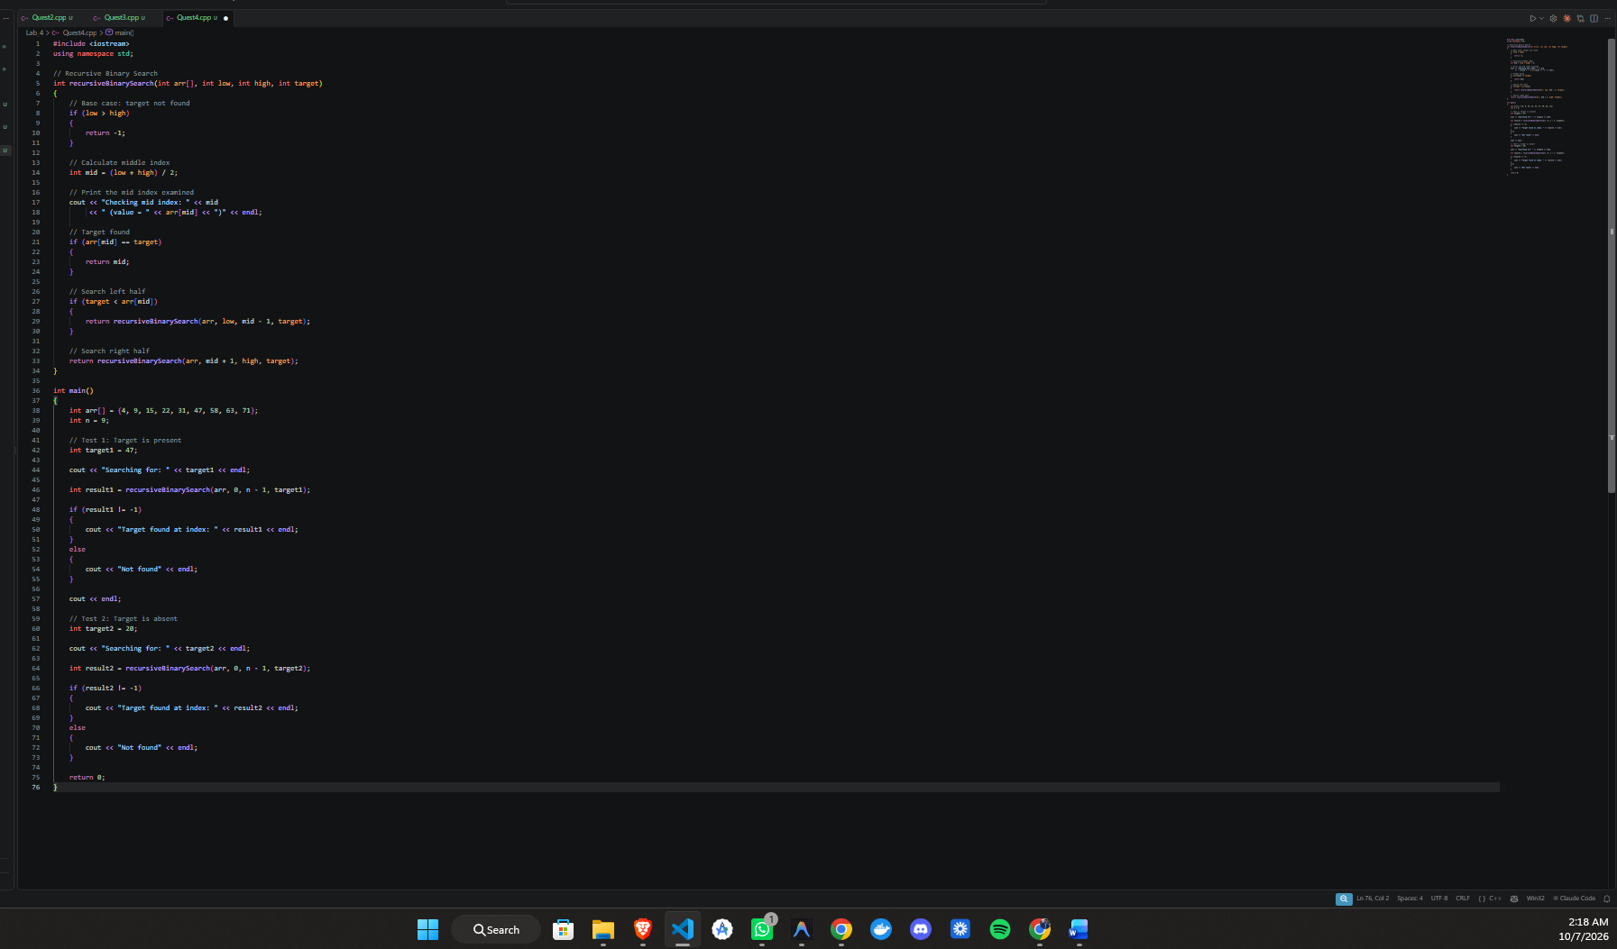

Output:

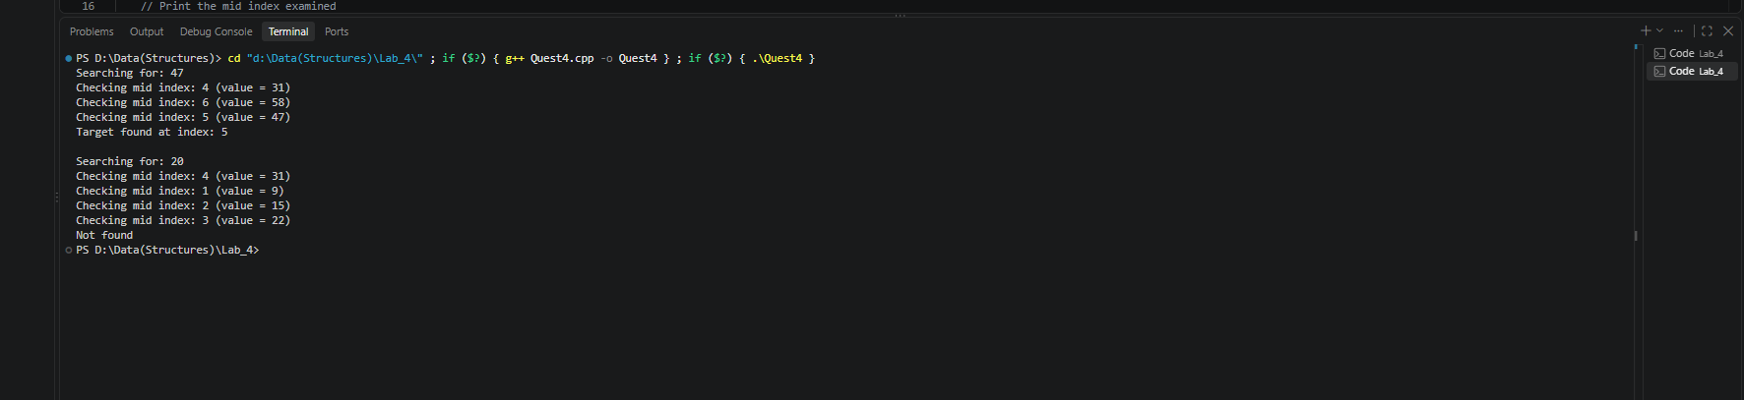

Explanation:
Iterative Binary Search:
Iterative binary search uses a while loop to repeatedly update low, high, and mid. It does not create new function calls for each step, so it generally uses less memory.
Recursive Binary Search:
Recursive binary search calls the same function again with a smaller search range. Each call creates a new function-call stack frame. It can be easier to understand because the algorithm directly expresses the idea of searching one half of the array at a time.
Conclusion:
Both methods have the same time complexity of O(log n). Iterative binary search usually has lower memory overhead, while recursive binary search provides a cleaner representation of the divide-and-conquer logic.

Task 4:
Given Array:
{7, 3, 5, 2, 8}

Bubble Sort is used to arrange the elements in ascending order. In each pass, adjacent elements are compared. If the left element is greater than the right element, they are swapped.

PASS 1
Initial Array:
7 3 5 2 8
Comparison 1: Compare 7 and 3
Since 7 > 3, swap them.
After swap:
3 7 5 2 8
Comparison 2: Compare 7 and 5
Since 7 > 5, swap them.
After swap:
3 5 7 2 8
Comparison 3: Compare 7 and 2
Since 7 > 2, swap them.
After swap:
3 5 2 7 8
Comparison 4: Compare 7 and 8
Since 7 < 8, no swap.

Array after Pass 1:
3 5 2 7 [8]

Sorted suffix: [8]
PASS 2

Initial Array:
3 5 2 7 [8]

Comparison 1: Compare 3 and 5
Since 3 < 5, no swap.
Array:
3 5 2 7 8
Comparison 2: Compare 5 and 2
Since 5 > 2, swap them.
After swap:
3 2 5 7 8
Comparison 3: Compare 5 and 7
Since 5 < 7, no swap.
Array after Pass 2:
3 2 5 [7] [8]
Sorted suffix: [7, 8]
PASS 3
Initial Array:
3 2 5 [7] [8]
Comparison 1: Compare 3 and 2
Since 3 > 2, swap them.
After swap:
2 3 5 7 8
Comparison 2: Compare 3 and 5
Since 3 < 5, no swap.
Array after Pass 3:
2 3 [5] [7] [8]
Sorted suffix: [5, 7, 8]
PASS 4
Initial Array:
2 3 [5] [7] [8]
Comparison 1: Compare 2 and 3
Since 2 < 3, no swap.
Array after Pass 4:
[2] [3] [5] [7] [8]
Sorted suffix: [2, 3, 5, 7, 8]
The complete array is now sorted.
PASS-BY-PASS SUMMARY
Pass 1:
3 5 2 7 [8]
Sorted suffix: [8]
Pass 2:
3 2 5 [7] [8]
Sorted suffix: [7, 8]
Pass 3:
2 3 [5] [7] [8]
Sorted suffix: [5, 7, 8]
Pass 4:
[2] [3] [5] [7] [8]
Sorted suffix: [2, 3, 5, 7, 8]
FINAL SORTED ARRAY
{2, 3, 5, 7, 8}
OBSERVATION
After every pass of Bubble Sort, the largest element from the unsorted portion moves to its correct position at the end of the array. Therefore, the sorted suffix increases by one element after each pass.

Task 5:
Implement Optimized Bubble Sort Build a correct bubble-sort program with early stopping. And Submit: C++ program + screenshot showing at least three passes.
Code:
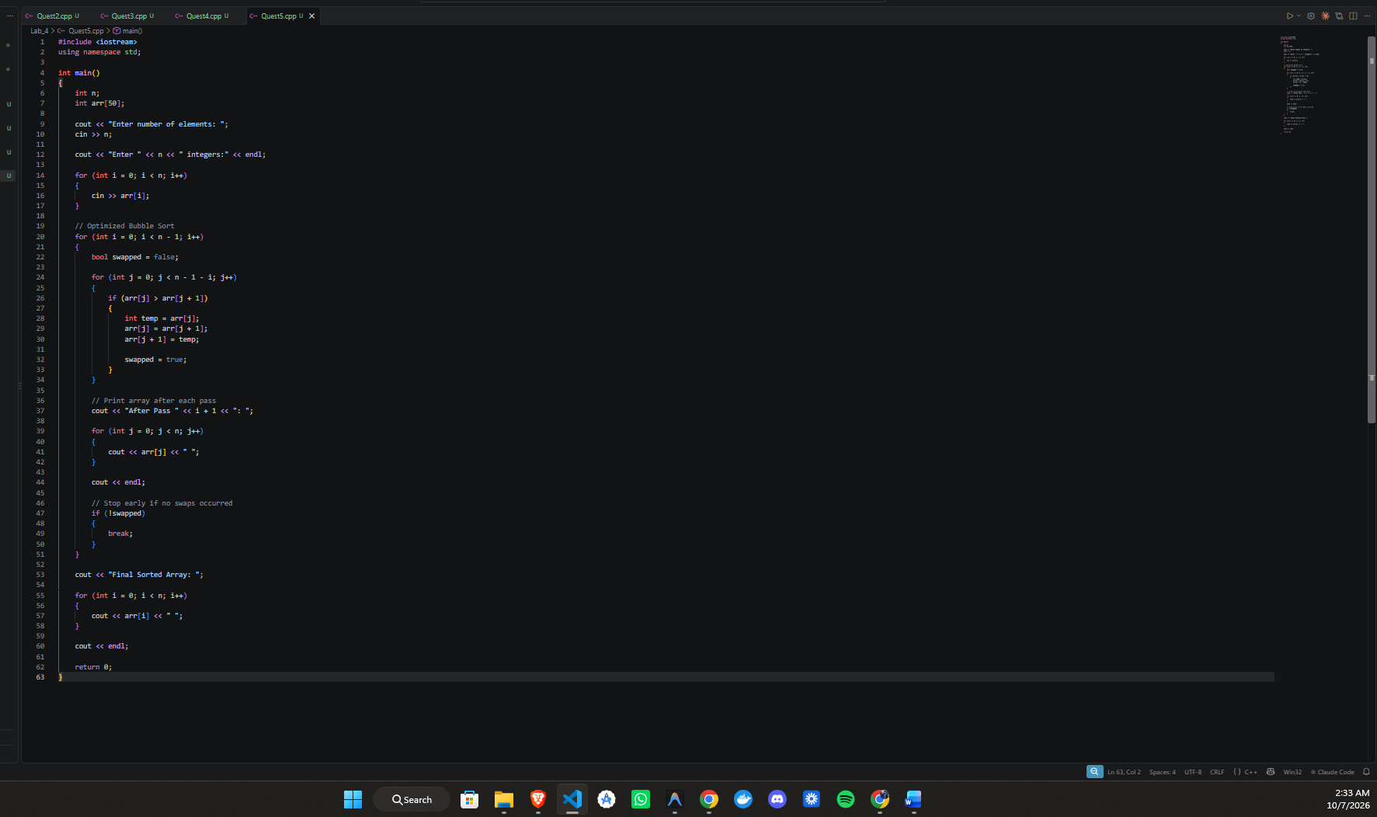

Output:
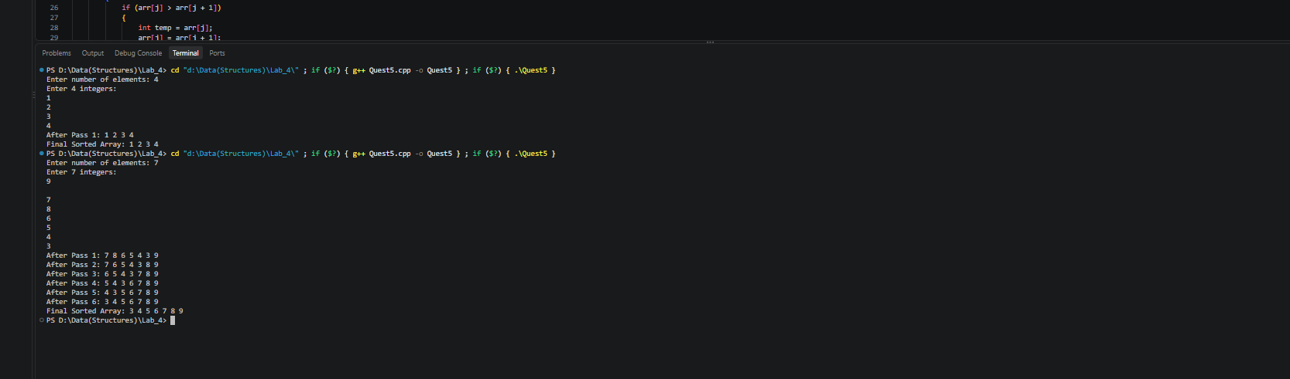

Task 6:
Measure Bubble Sort Work Objective: Connect the algorithm to comparisons and swaps. And Submit: A small results table plus the C++ program/output screenshots.

Code:
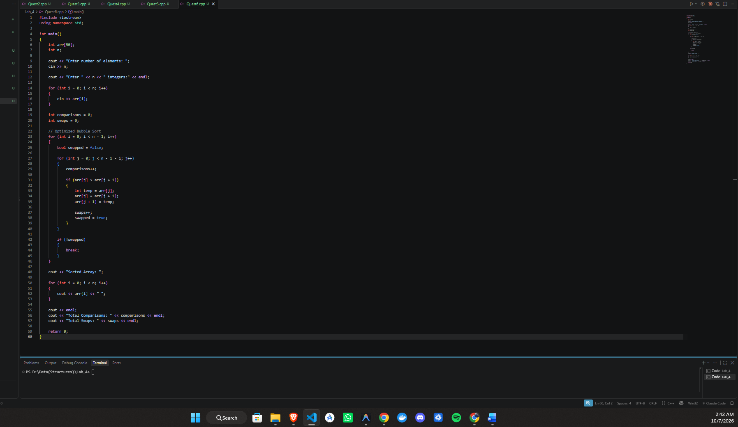

Output:
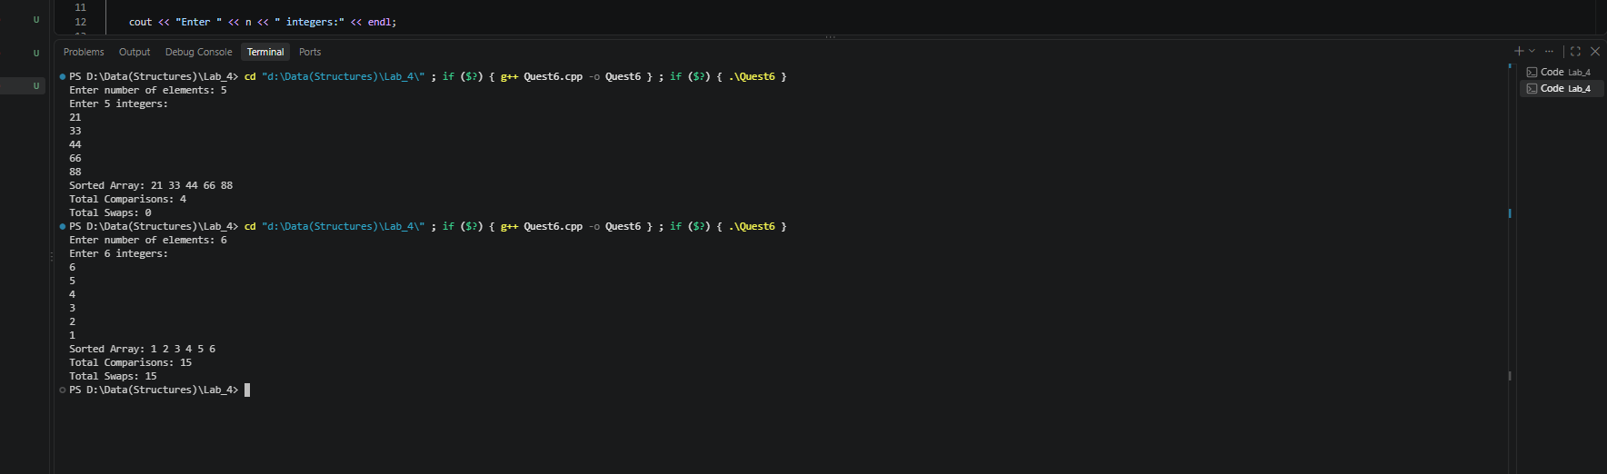
Explanation
For the already sorted array, the first pass makes 5 comparisons and performs no swaps, so the optimized Bubble Sort stops immediately. For the reverse-sorted array, every comparison requires a swap, so the algorithm continues through all passes and performs more work

Task 7:
Practice tracking minIndex before coding. Submit: A complete selection-sort trace for all passes.

Given Array:
{29, 10, 14, 37, 13}
Selection Sort finds the smallest value in the unsorted portion and swaps it with the first element of that portion.

Initial Array
29 10 14 37 13

Pass 1
i = 0
Start:
29 10 14 37 13
^
i = 0
Find the minimum value from index 0 to 4:
- 29 → current minimum
- 10 → smaller than 29 → minIndex = 1
- 14 → greater than 10
- 37 → greater than 10
- 13 → greater than 10
Minimum value = 10

minIndex = 1
Swap arr[0] and arr[1]:
10 29 14 37 13
Sorted prefix:
[10] 29 14 37 13

Pass 2
i = 1
Start:
[10] 29 14 37 13
^
i = 1
Find the minimum from index 1 to 4:
- 29 → current minimum
- 14 → smaller → minIndex = 2
- 37 → greater than 14
- 13 → smaller → minIndex = 4
Minimum value = 13
minIndex = 4
Swap arr[1] and arr[4]:
10 13 14 37 29
Sorted prefix:
[10] [13] 14 37 29

Pass 3
i = 2
Start:
[10] [13] 14 37 29
^
i = 2
Find the minimum from index 2 to 4:
- 14 → current minimum
- 37 → greater than 14
- 29 → greater than 14
Minimum value = 14
minIndex = 2
Since i and minIndex are the same, no actual swap is needed.
Array remains:
10 13 14 37 29
Sorted prefix:
[10] [13] [14] 37 29

Pass 4
i = 3
Start:
[10] [13] [14] 37 29
^
i = 3
Find the minimum from index 3 to 4:
- 37 → current minimum
- 29 → smaller → minIndex = 4
Minimum value = 29
minIndex = 4
Swap arr[3] and arr[4]:
10 13 14 29 37
Sorted prefix:
[10] [13] [14] [29] [37]

Complete Selection Sort Trace

Pass | i | Minimum Value | minIndex | Swap | Array After Pass
1 | 0 | 10 | 1 | 29 ↔ 10 | [10] 29 14 37 13
2 | 1 | 13 | 4 | 29 ↔ 13 | [10] [13] 14 37 29
3 | 2 | 14 | 2 | No swap | [10] [13] [14] 37 29
4 | 3 | 29 | 4 | 37 ↔ 29 | [10] [13] [14] [29] [37]

Final Sorted Array
{10, 13, 14, 29, 37}
Observation: After every pass, the smallest element from the unsorted portion is placed at the correct position. Therefore, the sorted prefix grows by one element after each pass.

Task 8:
Implement minimum selection and placement. And submit C++ program + output showing the selected minimum on every pass.
Code:

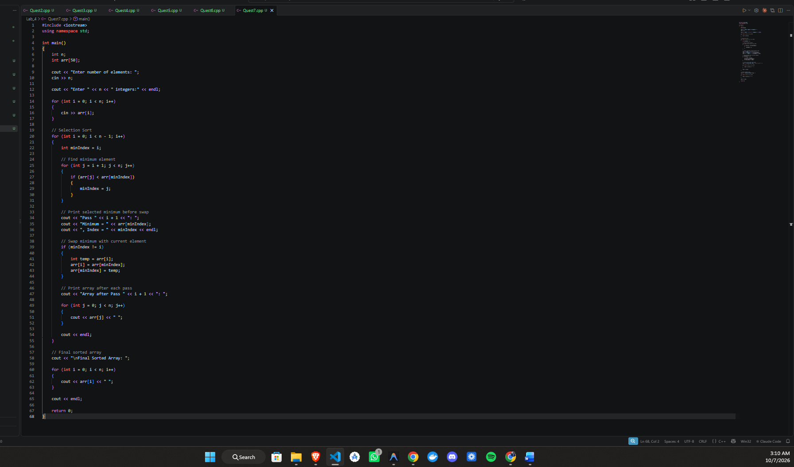

Output:
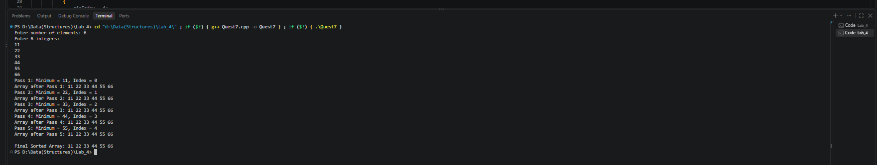

Task 9:
Selection Sort in Descending Order, Objective: Adapt the same structure by changing the selection rule. Submit: Modified program + output + comparison/swap counts.
Code:
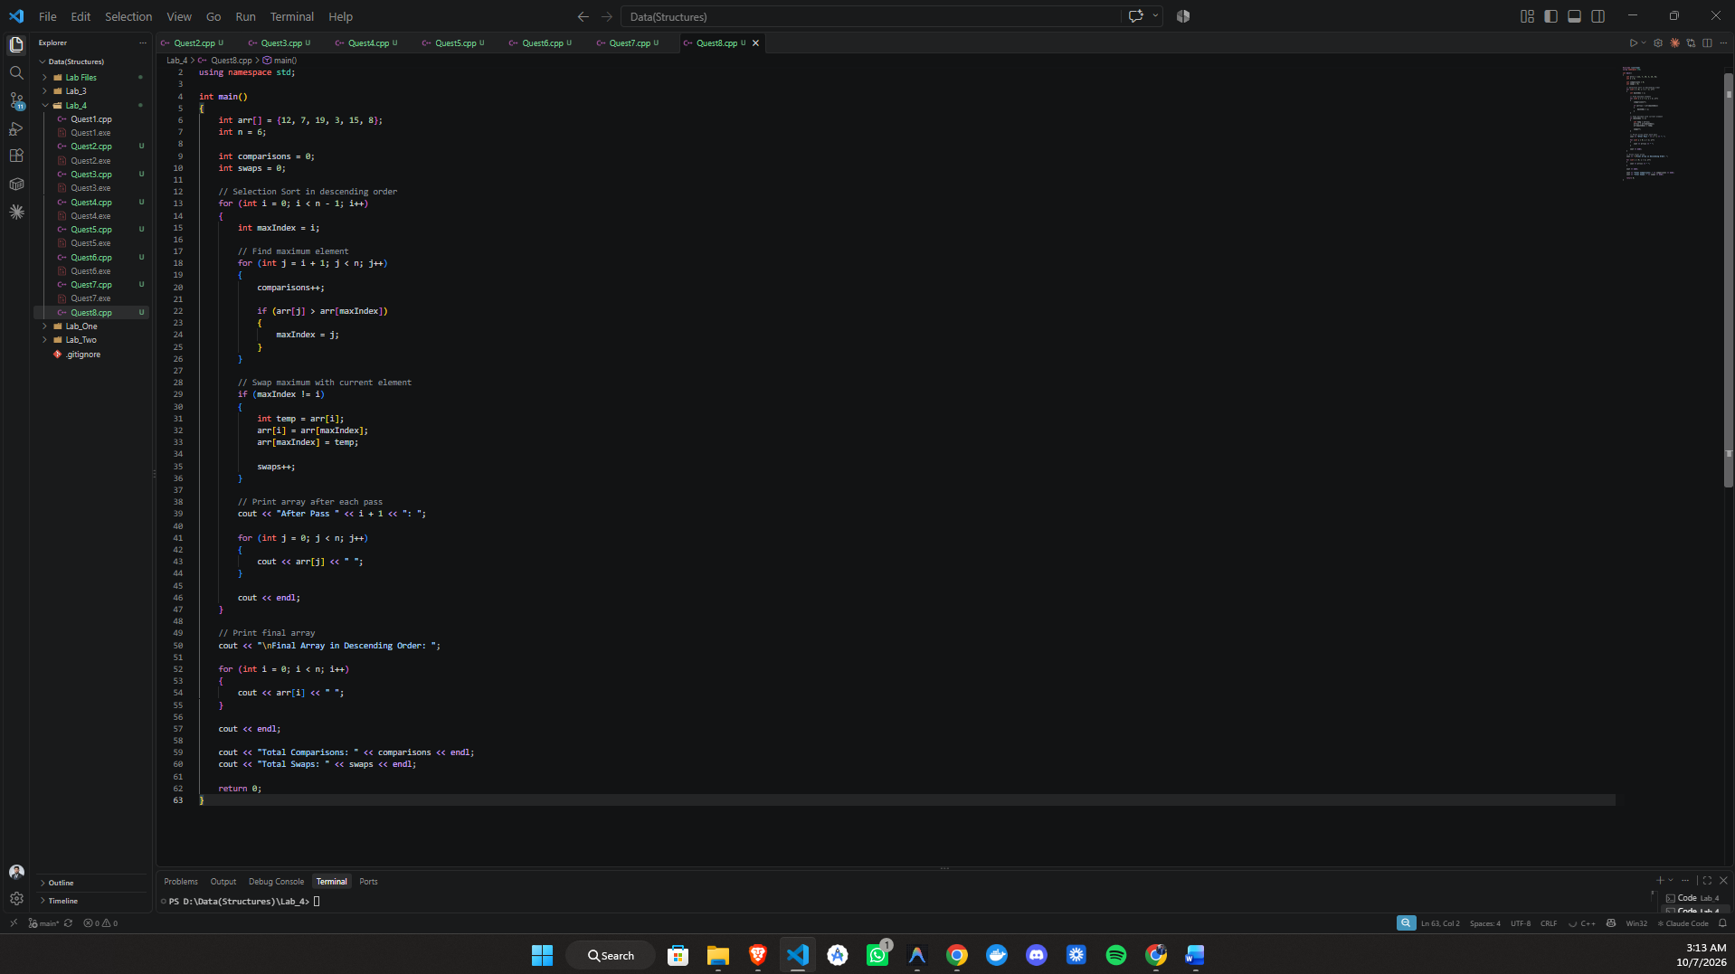

Output:
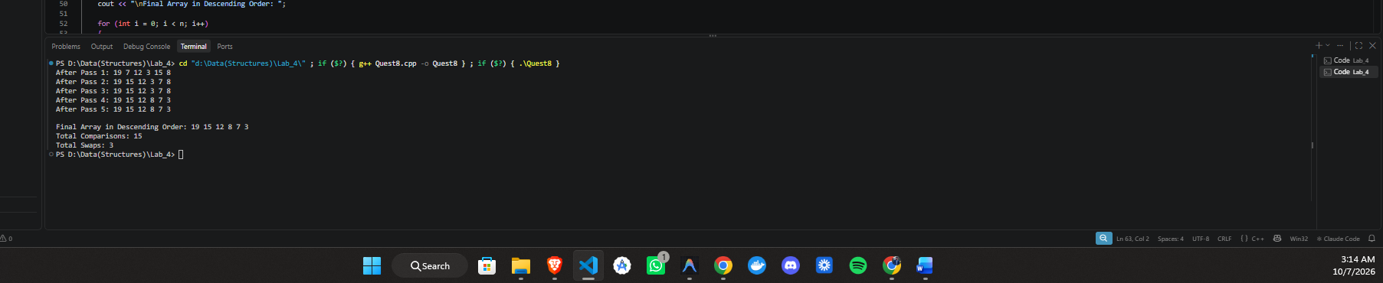

Task 10:
Visualize Keys and Shifts: Understand the movement that happens before insertion.

Given Array:
{8, 4, 6, 2, 7}
Insertion Sort takes one value at a time (called the key), shifts larger values one position to the right, and then places the key in its correct position.

INITIAL ARRAY
8 4 6 2 7
Initially, the sorted prefix contains only:
[8]

PASS 1
Index: 1
Key: 4
Compare 4 with 8.
Since 8 > 4, shift 8 one position to the right.
Shift:
8 → right
Array after shift:
8 8 6 2 7
Place the key 4 in its correct position.
Array after placing key:
4 8 6 2 7
Sorted prefix:
[4, 8]

PASS 2
Index: 2
Key: 6
Compare 6 with 8.
Since 8 > 6, shift 8 one position to the right.
Shift:
8 → right
Array after shift:
4 8 8 2 7
Compare 6 with 4.
Since 4 < 6, stop shifting.
Place the key 6.
Array after placing key:
4 6 8 2 7
Sorted prefix:
[4, 6, 8]

PASS 3
Index: 3
Key: 2
Compare 2 with 8.
Since 8 > 2, shift 8 one position to the right.
Array after shift:
4 6 8 8 7
Compare 2 with 6.
Since 6 > 2, shift 6 one position to the right.
Array after shift:
4 6 6 8 7
Compare 2 with 4.
Since 4 > 2, shift 4 one position to the right.
Array after shift:
4 4 6 8 7
There are no more elements to the left.
Place the key 2 at index 0.
Array after placing key:
2 4 6 8 7
Sorted prefix:
[2, 4, 6, 8]

PASS 4
Index: 4
Key: 7
Compare 7 with 8.
Since 8 > 7, shift 8 one position to the right.
Array after shift:
2 4 6 8 8
Compare 7 with 6.
Since 6 < 7, stop shifting.
Place the key 7.
Array after placing key:
2 4 6 7 8
Sorted prefix:
[2, 4, 6, 7, 8]

COMPLETE DRY RUN SUMMARY
Pass 1:
Key = 4
Shifted = 8
Array = 4 8 6 2 7
Sorted prefix = [4, 8]
Pass 2:
Key = 6
Shifted = 8
Array = 4 6 8 2 7
Sorted prefix = [4, 6, 8]
Pass 3:
Key = 2
Shifted = 8, 6, 4
Array = 2 4 6 8 7
Sorted prefix = [2, 4, 6, 8]
Pass 4:
Key = 7
Shifted = 8
Array = 2 4 6 7 8
Sorted prefix = [2, 4, 6, 7, 8]
FINAL SORTED ARRAY
{2, 4, 6, 7, 8}

OBSERVATION
In each insertion, the key is temporarily stored while larger elements in the sorted prefix are shifted one position to the right. After all required shifts are completed, the key is placed into the empty position, increasing the size of the sorted prefix by one element.

Task 11:
Translate shifting and insertion into C++. C++ program + output showing every insertion step and the shift count.

Code:

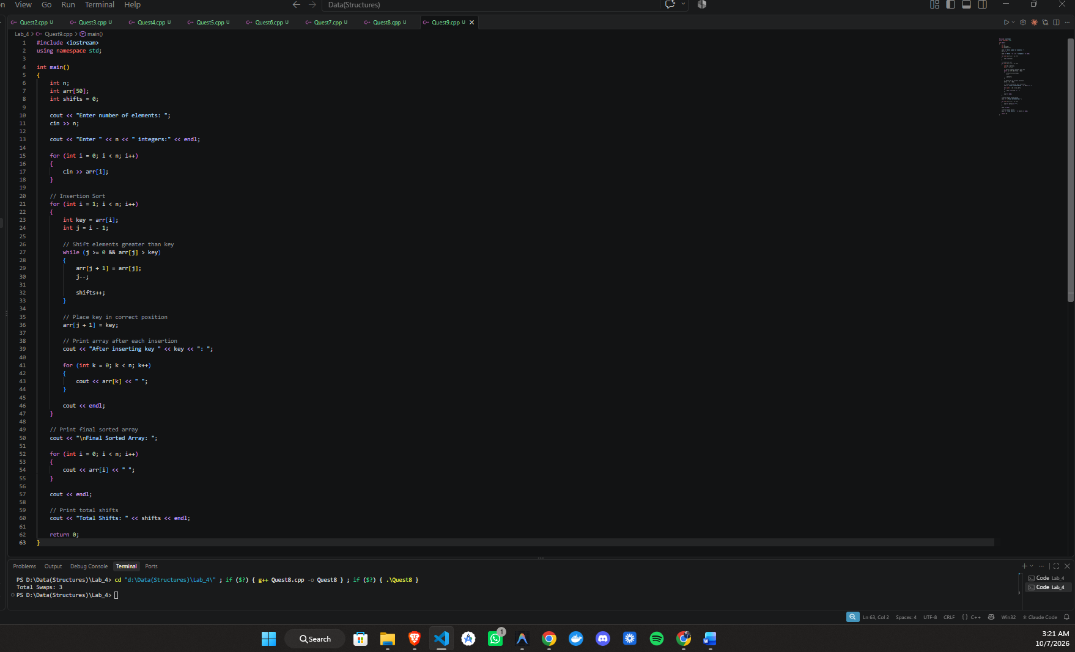

Output:

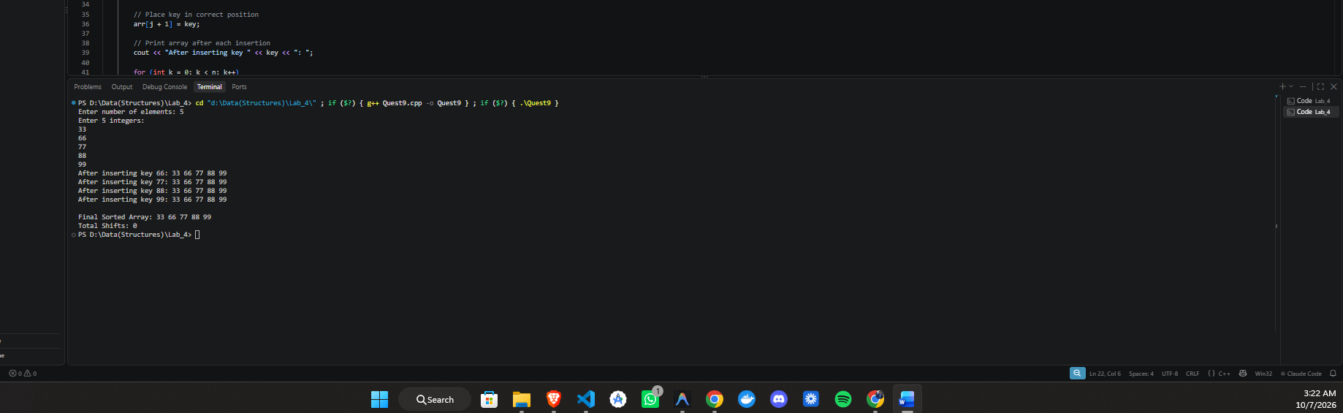

Task 12:
Combine insertion sort and binary search into one complete workflow. One complete C++ program + screenshots of both test cases.

Code:
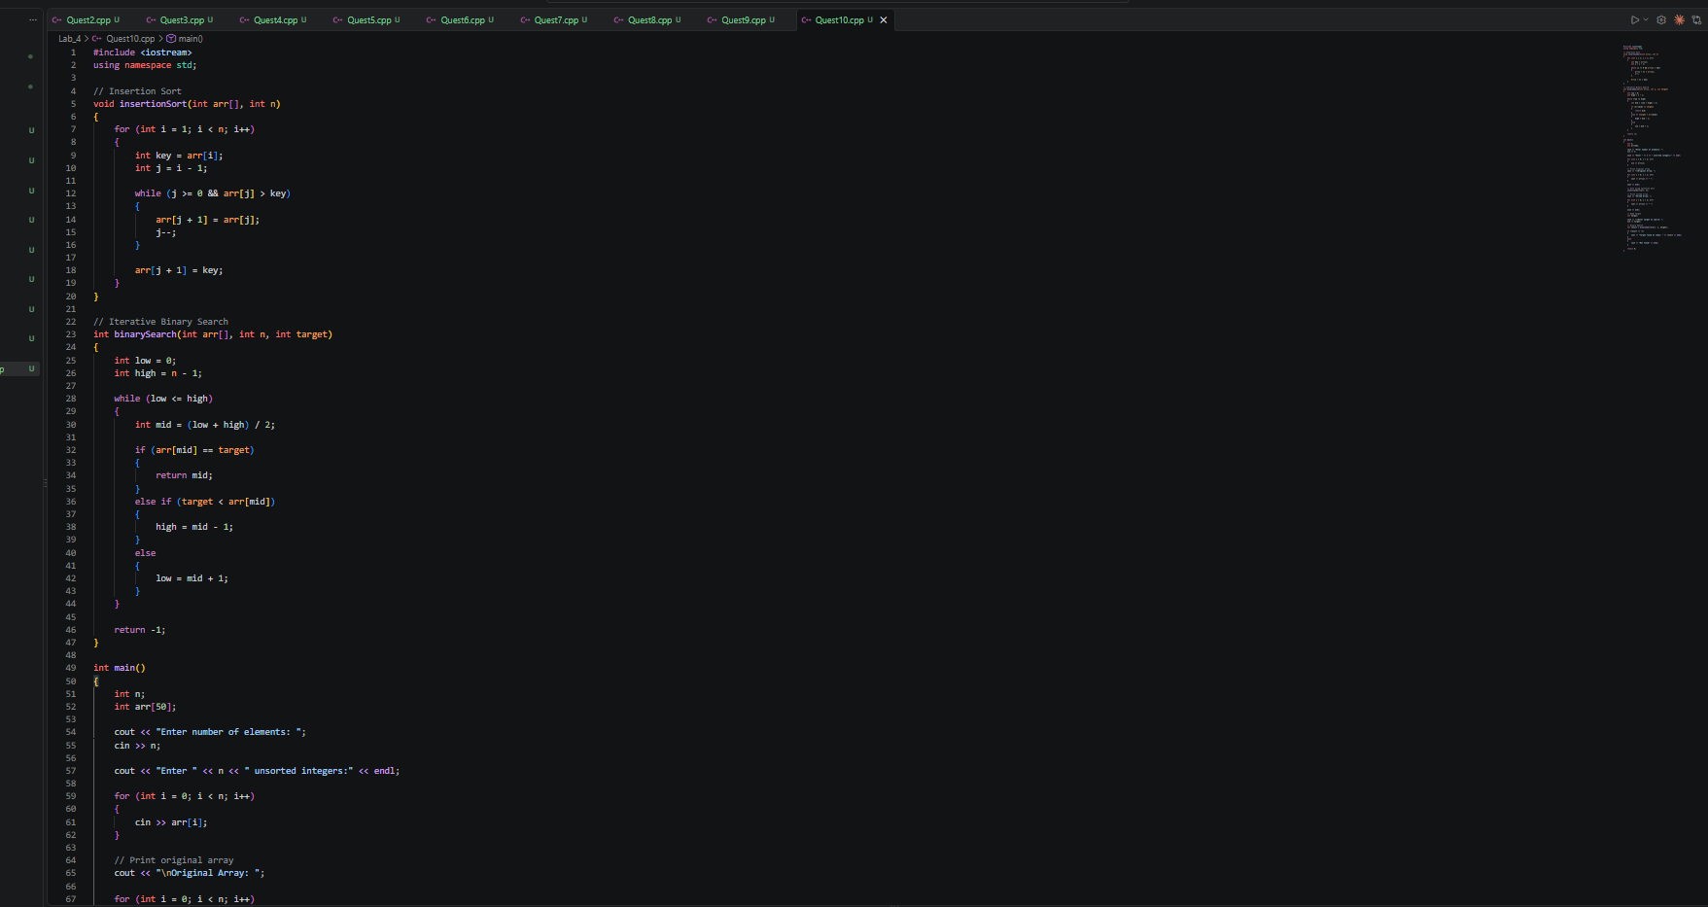
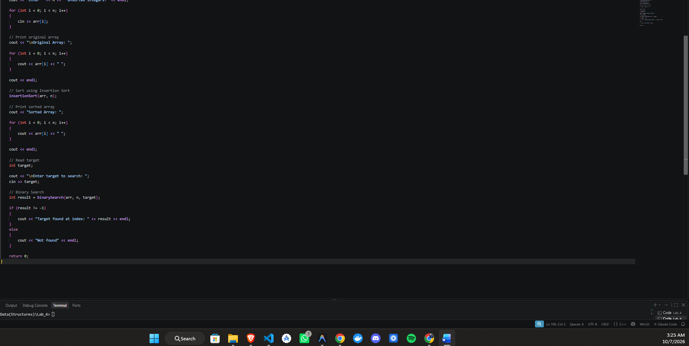

Output:

